

Progress Report

Group No: 2020-21/41 Date of submission:19/03/21

Project Name: The Tajmahal Beverages

Roll No | Exam No | Name | Sign
120 | 3253 | PATRAWALA MOHAMMED ABBASHBHAI | 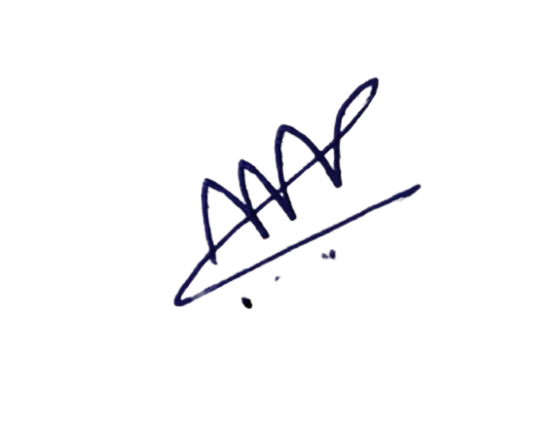
153 | 3280 | SHAIKH AADIL JAVED | 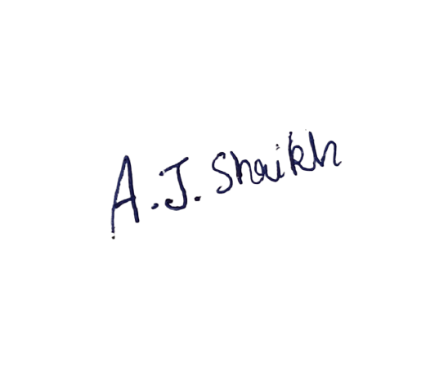

Work Done during Last Week | Requirement gathering, Database design and learned C#.
Plan for Next Week | Completing tables and implementing admin panel

Remarks (if any):_________________________________________________________

_______________________________________________________________________

_______________________________________________________________________

Name of Project Guide | Prof. Nainesh Gathiyawala | Sign:

